For classification task of supervised learning algorithms
Various ways to check the performance of our machine learning algorithm are –
- Confusion matrix
- Accuracy
- Precision
- Recall
- Specificity
- F1 score
- Precision-Recall or PR curve
- ROC (Receiver Operating Characteristics) curve
True positives (TP): Predicted positive and are actually positive.
False positives (FP): Predicted positive and are actually negative.
True negatives (TN): Predicted negative and are actually negative.
False negatives (FN): Predicted negative and are actually positive.

Confusion matrix
It’s just a representation of the above parameters in a matrix format. Better visualization is always good :)
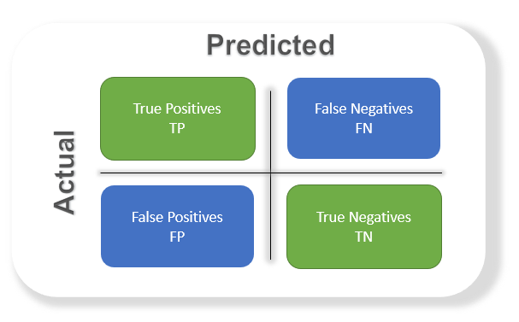

Accuracy
The most commonly used metric to judge a model and is actually not a clear indicator of the performance. The worse happens when classes are imbalanced.
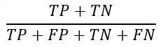
Take for example a cancer detection model. The chances of actually having cancer are very low. Let’s say out of 100, 90 of the patients don’t have cancer and the remaining 10 actually have it.

Precision
Percentage of positive instances out of the total predicted positive instances. Here denominator is the model prediction done as positive from the whole given dataset. Take it as to find out ‘how much the model is right when it says it is right’.
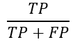

Recall/Sensitivity/True Positive Rate
Percentage of positive instances out of the total actual positive instances. Therefore denominator (TP + FN) here is the actual number of positive instances present in the dataset. Take it as to find out ‘how much extra right ones, the model missed when it showed the right ones’.
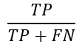

Specificity
Percentage of negative instances out of the total actual negative instances. Therefore denominator (TN + FP) here is the actual number of negative instances present in the dataset. It is similar to recall but the shift is on the negative instances. Like finding out how many healthy patients were not having cancer and were told they don’t have cancer. Kind of a measure to see how separate the classes are.
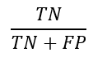

F1 score
It is the harmonic mean of precision and recall. This takes the contribution of both, so higher the F1 score, the better. See that due to the product in the numerator if one goes low, the final F1 score goes down significantly. So a model does well in F1 score if the positive predicted are actually positives (precision) and doesn't miss out on positives and predicts them negative (recall).
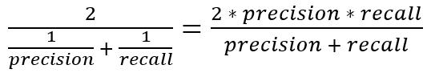

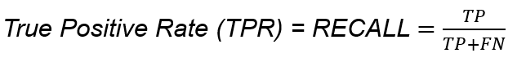

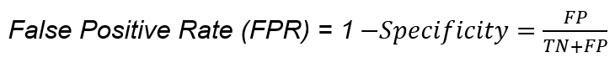

Not required as per syllabus - PR curve, ROC Curve. Can read if interested

PR curve
It is the curve between precision and recall for various threshold values. In the figure below we have 6 predictors showing their respective precision-recall curve for various threshold values. The top right part of the graph is the ideal space where we get high precision and recall. Based on our application we can choose the predictor and the threshold value. PR AUC is just the area under the curve. The higher its numerical value the better.
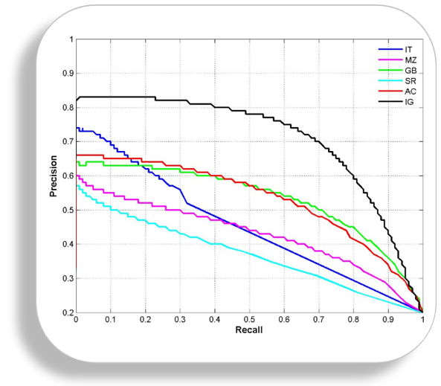

ROC curve
ROC stands for receiver operating characteristic and the graph is plotted against TPR and FPR for various threshold values. As TPR increases FPR also increases. As you can see in the first figure, we have four categories and we want the threshold value that leads us closer to the top left corner. Comparing different predictors (here 3) on a given dataset also becomes easy as you can see in figure 2, one can choose the threshold according to the application at hand. ROC AUC is just the area under the curve, the higher its numerical value the better.

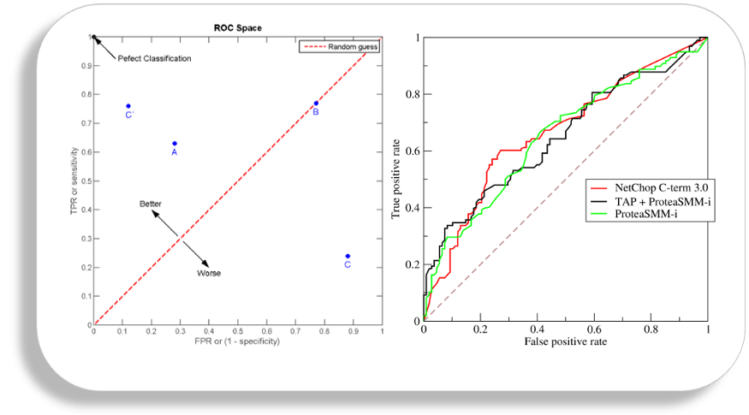

PR vs ROC curve
Both the metrics are widely used to judge a models performance.
Which one to use PR or ROC?
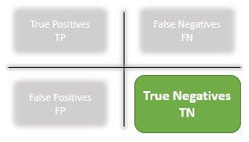
The answer lies in TRUE NEGATIVES.
Due to the absence of TN in the precision-recall equation, they are useful in imbalanced classes. In the case of class imbalance when there is a majority of the negative class. The metric doesn’t take much into consideration the high number of TRUE NEGATIVES of the negative class which is in majority, giving better resistance to the imbalance. This is important when the detection of the positive class is very important.
Like to detect cancer patients, which has a high class imbalance because very few have it out of all the diagnosed. We certainly don’t want to miss on a person having cancer and going undetected (recall) and be sure the detected one is having it (precision).
Due to the consideration of TN or the negative class in the ROC equation, it is useful when both the classes are important to us. Like the detection of cats and dog. The importance of true negatives makes sure that both the classes are given importance, like the output of a CNN model in determining the image is of a cat or a dog.

Regression metrics
Evaluation metrics for regression models are quite different than the above metrics we discussed for classification models because we are now predicting in a continuous range instead of a discrete number of classes. If your regression model predicts the price of a house to be $400K and it sells for $405K, that's a pretty good prediction. However, in the classification examples we were only concerned with whether or not a prediction was correct or incorrect, there was no ability to say a prediction was "pretty good". Thus, we have a different set of evaluation metrics for regression models.

Explained variance compares the variance within the expected outcomes, and compares that to the variance in the error of our model.
V(ytrue,ypred)=1−Var(ytrue−ypred)ytrue

Mean squared error is simply defined as the average of squared differences between the predicted output and the true output. Squared error is commonly used because it is agnostic to whether the prediction was too high or too low, it just reports that the prediction was incorrect.
MSE(ytrue,ypred)=(1/nsamples)*∑(ytrue−ypred)²
Root Mean Squared Error – root over of entire MSE formula.
The R² coefficient represents the proportion of variance in the outcome that our model is capable of predicting based on its features.

R² (y_{true,} y_{pred} ) = 1 - ∑(y_{true} – y_{pred} )² /∑(y_{true} – y´)²

Where, y´ = 1/n_{samples} ∑y_{true}

Mean Absolute Error – less biased for large errors(outliers) but also may not be adequately representing large errors. (L1 loss)

MSE – Highly biased for large errors(outliers). (L2 loss)

